Approximations and coffee cups: how geometry applies to life

Everyday life presents us with any interesting - and often beautiful - geometries. This ranges from flowers to trees, to buildings, to benchtops. The accuracy with which we can describe these objects mathematically has a great deal of impact on how well we make predictions. Consider a relatively simple aspect of an object, volume. All three-dimensional shapes have volume. But, how accurately can we calculate it for everyday objects? Thinking about geometry in terms of objects in real life has the capacity to influence the way in which we think about future discoveries of the field and all the connected fields such as computer science, number theory, non-Euclidean geometry, complex analysis etc. and the various applications and representations of these fields in the real world. With this thinking in mind, I would like to portray an example of Euclidean geometry being applied to real life and the various discrepancies that come from using Euclidean geometry when calculating the volume of irregular objects in the real world and explore some of the alternate methods of calculating volume with an item on my breakfast table that I thought was very interesting: a coffee cup.

The aim of this investigation is to approximate volume of irregular objects (a coffee cup in this case) and compare it to the volume measured using Archimedes method and to discuss the various ways available to calculate the volume of irregular objects using examples.

## 

Looking at the coffee cup, I thought about how I could divide up the object into portions that I could calculate the volume of. In this case, I immediately saw the frustums and trapezoidal prisms that could be made from the cup.

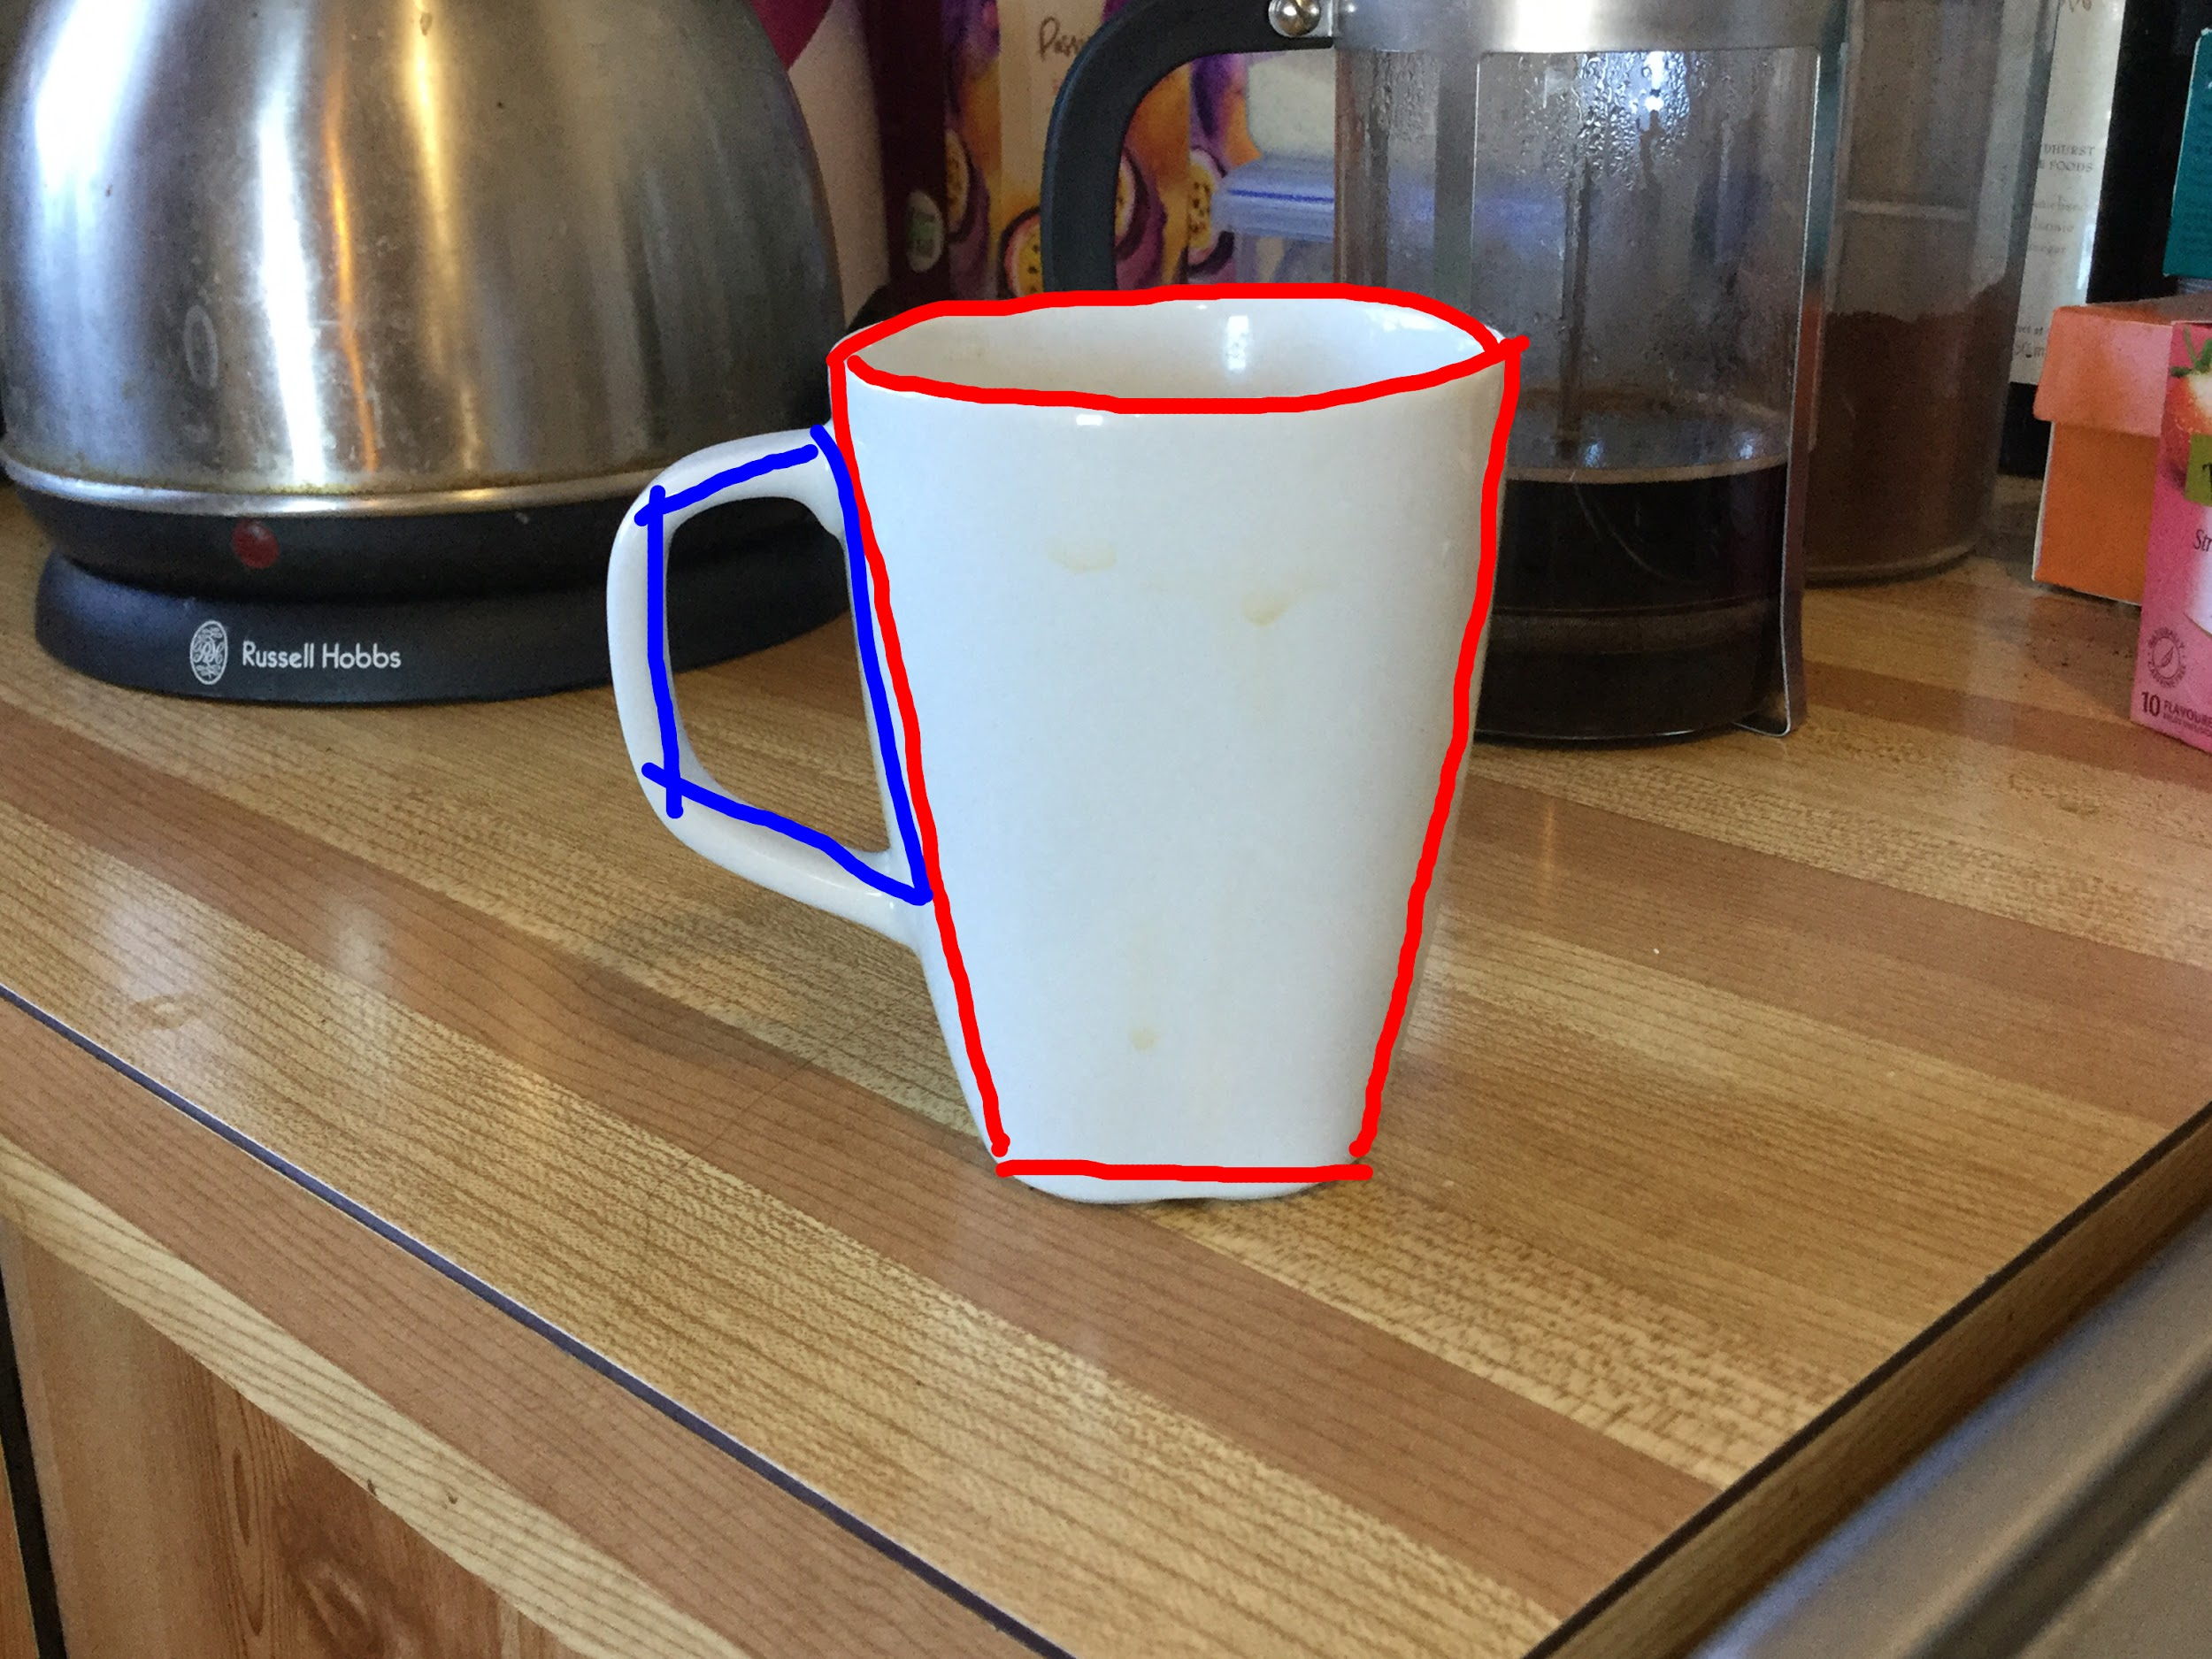

The volume of a frustum is:

Which in this context would involve subtracting the inner frustum from the outer frustum

The dimensions of the coffee cup are as follows:

And the dimensions of the handle are:

Which can be applied to formula of a trapezoidal prism like this:

We can the subtract the inner trapezoidal prism as follows:

Meaning the total volume of the coffee cup should be:

Now to measure the coffee cups volume, I used the Archimedes method. Submerging the coffee cup in water and checking the change in the water level. Given the dimensions of the container (32 cm x 40.5cm) the expected rise in the water level from 10 cm would be 0.06306038 cm. However, when actually measured, the cup displays a rise of 0.1 cm equivalent to 129.6 cm3 which is almost a 37% error. The reason for some of these inaccuracies. Firstly, the thickness of the cup is not uniform throughout. Closer to bottom it becomes significantly thicker - a design feature implemented to prevent the surface below charring or burning - that threw out the estimate significantly. There is also the error of measurement to be considered. Not only in the estimations but, also the experiment performed. The errors can clearly be explained by the error of measurement which in this case is an average error of approximately 11%. This is an amalgamation of all the measurements I took, including the measurements of the sink used to predict the water level change. This could explain - at least in part - the discrepancies of the estimate and experiment. In addition, the methodology of measuring the water change was crude, I simply checked the water difference with a ruler that was placed in prior to the cup being put in. This measurement would have clearly been distorted by the refraction of the light in the water. Still, despite these inaccuracies in measurement, the primary issue with the estimation is that the regular shapes used to model the coffee cup do not accurately reflect the geometry of the object. Whilst a frustum approximates the coffee cup it is not exactly the same and therefore the volumes calculated are not 100% accurate to the real object. Euclidean geometry doesn’t have the tools to accurately and easily calculate the volume of irregular shapes. You must divide up the shape into small sections and calculate based on these divisions of the object and it still may be somewhat inaccurate. This demonstration shows the ways in which errors occur from applying these geometric techniques to objects in the real world and given the sort of precision we require when modelling objects in various fields of science and applied mathematics it is pertinent that we have the mathematical tools to adequately model such objects.

Given the impracticality of using the techniques of Euclidean geometry in any precise manner, alternatives must be found: enter differential geometry. Differential geometry is a discipline of mathematics that uses the techniques of calculus: differentiation, integration, infinite sums, limits etc. to solve problems in geometry. In the case of our problem, we would use integration and a technique called finding the volume of a revolution. This method takes a portion of an equation f(x) or f(y)and rotates it around the x or y respectively. Doing this means taking the volume of each dx slice and using f(x) as the radius for this 3d object. Let’s use an example of a simple 2d object: a cone. The 2d representation of this shape in this context is a straight line equation say which has this graph:

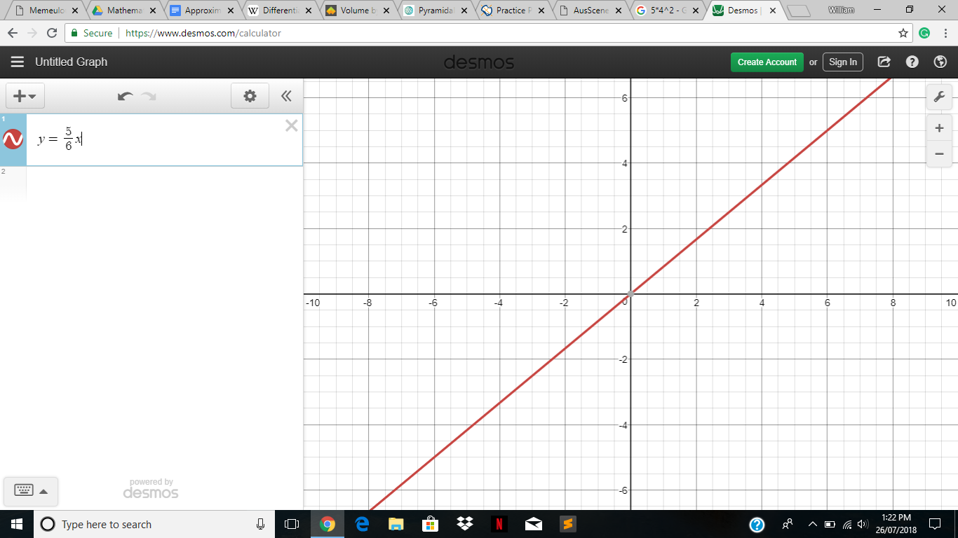

And let’s take the portion of 0 to 4 which is this:



And then rotate it 360° around the x-axis and then take sum the volume of each of these infinitesimally small slices using calculus. Similar to this:

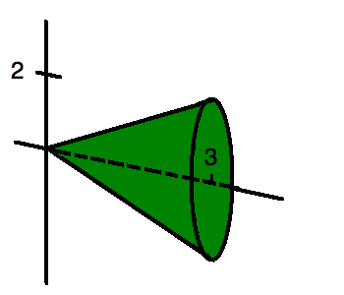

In this context, we have to use the volume of a cylinder and make the radius r equivalent to and taking a definite integral from .

In algebra it looks like this:

*Volume of a cylinder*

Volume of each slice.

Then we perform a definite integral on these volumes to add the infinitely many triangles of width dx:

The volume found via this method is . We know, however, find the volume of a cone with the formula and a cone with these dimensions namely a height of 4 units and a radius of units results in:

The two results are clearly equivalent showing that this method works in this case and in this instance it works in all cases similar to this. So, let’s see where this could be applied to other, irregular objects. Take the equation whose graph looks like this:

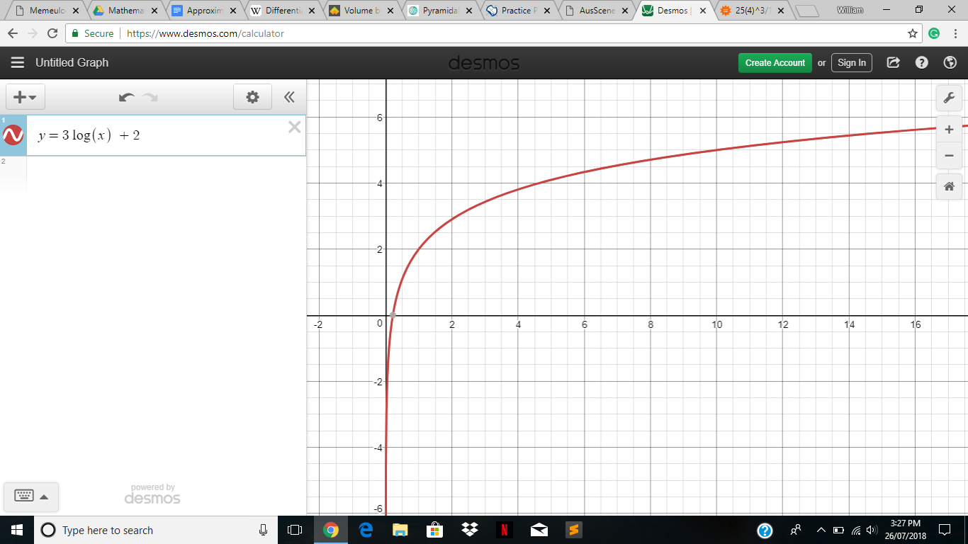

And we will only consider the portion from 0.215 to 10 which looks like this:



In 3d this looks somewhat similar to a wine glass top, or bullet. Regardless, this shape has no defined formula in Euclidean geometry. We simply do as before:

*Volume of a cylinder*

*Volume of each slice*

Then we do the same integral that we did before:

This method took a problem that would be essentially impossible to solve using Euclidean geometry and gave us a reliable answer. Well, why don’t we apply it to the coffee cup from before? Because can you imagine the absurd amount of time finding a curve like that would take! This method only for objects that for which we have an accurate 2d curve. This, whilst completely possible to find, is impractical for everyday situations. Also, this method does not work for things that have a square base because the radius is constant whilst it is rotated and therefore will always create a circular base. However, it performs functions that Euclidean geometry cannot and is extremely useful in cases where we’re working with purely mathematical objects in the way that a physicist or geometer would. There is the alternative of doing 3d integration to the object itself; approximating the object with a series of rectangular prisms that when there is an infinite number of them they are perfectly equivalent to the object itself. This method is also satisfactory for people who use need mathematical precision to a high level in the same way that a physicist, mathematician, geometer, engineer, or computer scientist would.

<https://www.wyzant.com/resources/lessons/math/calculus/integration/finding_volume>

<http://mathworld.wolfram.com/PyramidalFrustum.html>

<https://en.wikipedia.org/wiki/Differential_geometry>

<https://www.youtube.com/watch?v=WUvTyaaNkzM>

<https://www.youtube.com/watch?v=9vKqVkMQHKk>

<https://www.youtube.com/watch?v=S0_qX4VJhMQ>

<https://www.youtube.com/watch?v=YG15m2VwSjA>

<https://www.youtube.com/watch?v=m2MIpDrF7Es>

<https://www.youtube.com/watch?v=qb40J4N1fa4&t=587s>

<https://www.youtube.com/watch?v=kfF40MiS7zA&t=2s>

<https://www.youtube.com/watch?v=FnJqaIESC2s>

<https://www.youtube.com/watch?v=BLkz5LGWihw>

I would like to acknowledge the help of Mr Nunn and Mrs Campisi for their consistent help with this project.